EMILIO KARIUKI’S RELEVANCE IN SOCIAL MEDIA

X

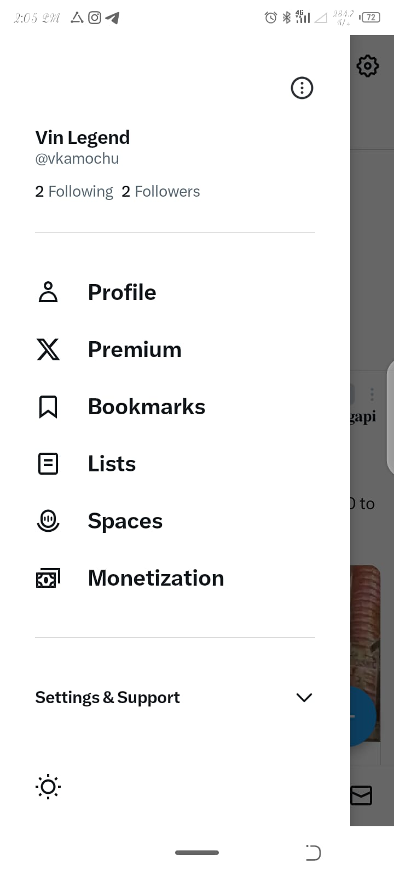

INSTAGRAM

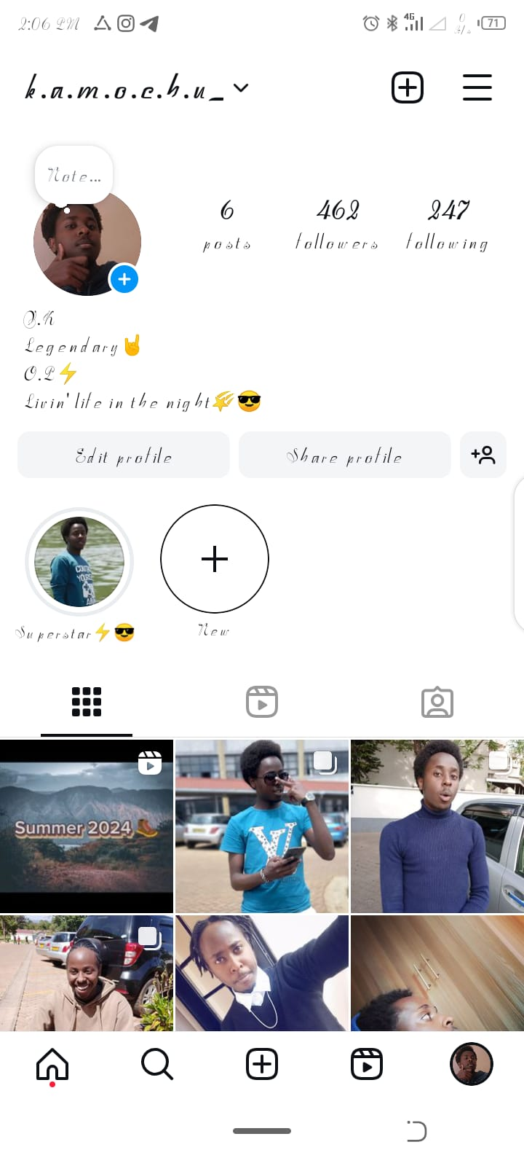

**LinkedIn**

